David L. Suddjian
Biological Consulting Services

801 Monterey Avenue, Capitola, CA 95010
Telephone 831· 479· 9603, email dsuddjian@aol.com

Summary of 2004
Marbled Murrelet Monitoring Surveys

In The Santa Cruz Mountains

Prepared for

Command Oil Spill Trustee Council

Prepared by

David L. Suddjian
Biological Consulting Services
801 Monterey Ave., Capitola, CA 95010

May 3, 2005
Final Report

INTRODUCTION

This report presents the results of Marbled Murrelet (Brachyramphus marmoratus, hereafter referred to as “murrelet”) monitoring surveys conducted in 2004 for the Command Oil Spill Trustee Council (COSTC) in the Santa Cruz Mountains at Big Basin Redwoods State Park, Portola Redwoods State Park, Butano State Park, and San Mateo County Memorial Park (Figure 1). These surveys were commissioned to assist the COSTC in restoration planning for potential projects benefiting the Marbled Murrelet.

Methods

Study Design

Dawn surveys were conducted at five stations in Big Basin, and at two stations each in Portola, Butano, and Memorial (Figure 1). Coverage at Butano, Memorial and one of the Portola stations augmented an existing long-term program of monitoring already established at Portola (since 1992) and Big Basin (since 1995). Presently each station in each park is surveyed three times annually from June to July, with two surveys at each in July. Two additional surveys are conducted at one of the Portola stations so that surveys occur on three consecutive mornings in late June to continue a pattern of coverage begun in 1992. Total surveys for each park are 15 at Big Basin, 8 at Portola, and six each at Butano and Memorial.

Location of Survey Stations

Criteria for station placement and the selection of sites was described in Suddjian 2004.

The five stations at Big Basin (“Redwood Meadow”, “100 Acre Woods”, “Blooms Creek”, “Huckleberry #17”, and “Sempervirens”) were established in 1995 in a dispersed array in the upper watershed of the East Fork of Waddell Creek (Figure 2). “Redwood Meadow” station is at the meadow near the beginning of the Redwood Loop Trail. “100 Acre Woods” station is on the North Escape Road at that road’s northern crossing of Opal Creek. “Blooms Creek” station is along East Ridge Trail east of Blooms Creek Campground. “Huckleberry #17” station is near site #17 in the tent cabins area of Huckleberry Campground. “Sempervirens” station is east of the Sempervirens Reservoir access road, midway between the reservoir and Lodge Road.

The “Peters Creek Bridge” station at Portola (established in 1992) is located on the bridge adjacent to the park’s main campground (Figure 3). “Iverson” station (established in 2003) is located where Iverson Trail crosses Pescadero Creek west of park headquarters (Figure 3).

At Butano (Figure 4), “Ben Ries” station (established in 2003) is on the main park road 50 meters before the road enters Ben Ries Campground, adjacent to campsite #1. “Little Butano Creek” station (established in 2003) is at a large landslide along a park service road that begins at the entrance to the campground.

At Memorial (Figure 5), “Sequoia” station (established in 2003) is in the Sequoia Flat Campground where the main camp road enters the “D” section of the camp. “Memorial” station (established in 2003) is at Pescadero Creek adjacent to the Tan Oak Flat Picnic Area, at the site of the “swimming pool” that was formerly created seasonally in the creek.

Dawn Murrelet Surveys

Dawn murrelet surveys followed the standard protocol for audio-visual surveys in forests (Pacific Seabird Group 2003). David Suddjian conducted all the surveys. In addition to the murrelet survey data, all bird species detected (noting time, estimates of numbers, and other pertinent information) were recorded, and two unlimited distance point counts were conducted during each dawn survey (Appendix 1). The point counts lasted 10 minutes and began at 0-5 minutes and 45 minutes after sunrise. Additional details of observations of Common Ravens (Corvus corax) and raptors (direction, distance, behavior, etc.), and a best estimate of the maximum number of Steller’s Jays (Cyanocitta stelleri) noted during each survey were also recorded.

Seasonal Timing of Coverage

Survey dates for each park in 2004 are given on Table 1. An effort was made to schedule coverage at each station on dates close to when surveys were conducted there in previous years.

Additional Information on Murrelet Occurrence at Big Basin

Appendix 2 presents a summary of survey results from the Redwood Meadow / Park Headquarters parking lot of Big Basin. A total of 151 surveys following the same methods as those of this study have been completed at this site since 1991, representing the longest unbroken series of data for murrelets from any site in the Santa Cruz Mountains, and offering an opportunity to examine long-term trends. In 2004 Suddjian conducted 14 additional surveys at the Redwood Meadow / Park Headquarters parking lot area from April 12 to July 25 that were not part of the COSTC contract.

Appendix 3 presents a summary of results from a USGS Breeding Bird Survey (BBS) route sampled by Suddjian from 1992 to 2004 that begins at Big Basin. While the BBS method is not specifically designed for monitoring murrelets at forest sites, it does provide a repeated measure of activity, and coverage for the BBS at Big Basin has been contemporaneous with the other monitoring efforts presented in this report.

Results

Marbled Murrelet

Dawn flight activity in 2004 is characterized below for each park. Subjective descriptors of “low, “moderate,” and “high” activity refer generally to total detection counts in the range of 0-10 detections, 11-50 detections, and >50 detections, respectively. Results of the 2004 murrelet surveys are shown on Table 1. Tables 2 and 3 compare activity in each park for every year the stations were sampled.

Big Basin Redwoods State Park

Activity in 2004 remained very low compared to the park’s known history of high activity, but continued the pattern of the most recent years (Suddjian 2003a, 2003b, and 2004). Total detections and detections of “occupied site behavior” (i.e., below canopy flights) were both very low in 2004, with the 15 surveys yielding just 77 total detections and only 7 detections of below canopy flights. Seven surveys (47%) had no detections at all. A pattern of a paucity of detections before sunrise, even on clear mornings, suggested limited nesting activity. The only observation of particular interest from any of the Big Basin surveys in 2004 was from “Redwood Meadow” on June 18.

“Redwood Meadow” is located at center of the murrelet activity in the East Fork Waddell watershed. Surveys there produced 43% of all Big Basin detections recorded in 2004, and all seven of the below canopy detections. Activity levels ranged from low to moderate (7-33 detections), with two or three detections of below canopy flights on each of the three surveys (Table 1). On June 18 a murrelet was observed flying over the meadow carrying a fish in its bill. The bird was first observed at 05:47 hr (sunrise) as it flew upstream over Opal Creek. It circled over the meadow two times at 0.6 canopy height before it left view flying upstream over Opal Creek. At 06:22 (35 minutes later) a bird was again seen flying upstream low over the creek and it appeared to also have a fish in its bill. However, the view of that bird was insufficient to be certain that it carried a fish. The observation of a murrelet carrying a fish indicates an active nest was somewhere in the vicinity. Murrelets are generally thought to fly in direct routes to nests while carrying food. The circling flight path seen at 05:47 hr suggested that the nest might be near the meadow itself, as in the immediate vicinity of a nest an adult murrelet may fly by the nest tree one or more times before actually approaching the nest branch to land (Singer et al. 1995).

Activity at “100 Acre Woods” was low on two surveys (0-2 detections), and moderate on the third (19 detections), but there were no detections of below canopy flights (Table 1). Nearly all the detections were of birds flying northward up the canyon of Opal Creek, and then turning back down the canyon, sometimes in the immediate vicinity of the station. Several detections clearly involved birds making repeated runs up and down the canyon.

Activity at “Huckleberry #17” was very low (0-1 detections; Table 1). The lone detection was of a series of four calls 200 meters to the southwest of the station. Given this paucity of activity, a detection 20:27 hr (15 minutes after sunset) on May 25 of one or two murrelets flying south over the western part of Huckleberry Campground is noteworthy (D. Suddjian pers. obs.).

Activity at “Blooms Creek” was very low (0-3 detections; Table 1). The three detections on the July 7 survey were all 250-400 meters distant to the northwest of the station. “Blooms Creek” has not had any occupied site detections recorded since early July 2001.

“Sempervirens” had no detections on any of the surveys (Table 1). There have been no detections at all on the nine surveys at “Sempervirens” in 2002-2004 since activity was last noted there in late July 2001.

Trends at Big Basin

Activity in 2004 continued the significant declining trend (p = 0.0003) that has been evident over recent years (Table 2, Figures 6 and 7). Each station individually exhibited the same general pattern of a decline from relative high activity in the beginning years of monitoring to very low activity in recent years (Figure 8). Data from the more extensive series of surveys at Redwood Meadow (Appendix 2) and from the BBS route (Appendix 3) match the pattern of decline documented by this study.

Portola Redwoods State Park

Activity at “Peters Creek Bridge” was moderate in late June (23-29 detections), increasing to high (75 detections) in mid-July, and then deceasing to moderate by late July (27 detections) (Table 1). Below canopy flights were infrequent on the June surveys, but increased somewhat in July (Table 1). None of the detections at “Peters Creek Bridge” had any particularly interesting behaviors. As has been typical at this station, murrelets approached the station from all directions and circling flights were fairly frequent.

Activity at “Iverson” was moderate to high on all three surveys (31-55 detections), with a moderately high frequency of below canopy flights (5-15) each day (Table 1). As was noted in 2003 (Suddjian 2004), “Iverson” station experienced a high degree of the daily murrelet “flight traffic” in and out of the Portola area, and there were also detections with extensive circling activity. There were multiple detections each day of murrelets flying below canopy over Pescadero Creek, which was used consistently as a flight corridor.

There were no observations of particular interest during any of the Portola surveys in 2004.

Trends at Portola

The only long term comparison available for Portola is for the three late June surveys at “Peters Creek Bridge” (Table 3). Activity in 2004 was lower than seven of the eight previous years for which data is available, but was similar to levels of activity in 2002 and 2003 (Table 3, Figure 9). Linear regression on average total detections over the whole period of 1992-2004 showed a marginally significant declining trend (p = 0.07; Figure 10), but regression on data just from 1994-2003 showed a highly significant trend (p = 0.006).

Average total detections at both stations over the whole survey period were lower in 2004 than 2003 (Figure 11), with the greatest difference between years for detections with occupied site behaviors (Figure 12).

Butano State Park

Activity at “Ben Ries” ranged from moderate to high (13-81 detections), and included below canopy flights on two of three surveys, and none on the others (Table 1). As in 2003 (Suddjian 2004), activity was oriented toward Little Butano Creek or up the canyon to the east, and included many detections of birds moving up or down the drainage. But in contrast to 2003, surveys in 2004 recorded notably more activity over or near the campground, and many more detections with occupied site behavior. The 81 detections recorded on July 23 was the third most of any survey in 2004, and exceeded totals for any of the surveys in the four parks conducted in 2003.

Activity at “Little Butano Creek” was moderate (22 detections) on the June survey, increasing to high in July (87-96 detections), with a relatively high frequency of below canopy flights on all three days (Table 1). Totals of 87 and 96 detections on the July surveys were the most recorded on any of the 2004 surveys for this study. Each survey recorded extensive movement by murrelets flying up and down the drainage, and circling over the canyon bottom in the vicinity of the station. The 38 below canopy flights observed on July 22 was more twice the number of such detections recorded on any other 2004 survey. Single detections on July 1 and July 23 may have involved brief tree landings and fly-outs within 100 meters to the southeast of the station, but the apparent landing site was not in view. There were no other observations of particular interest during any of the Butano surveys in 2004.

Trends at Butano

There is no long-term data available for Butano. Activity in 2004 was markedly higher than in 2003, with about twice as many total detections and three times as many detections with occupied site behavior (Table 2, Figures 11 and 12).

San Mateo County Memorial Park

“Memorial” had very low activity (0-3 detections), and no detections of occupied site behavior (Table 1). The only survey with detections (3 on July 8) had two audio detections of murrelets apparently circling northwest of the station, and one of a pair flying above canopy going downstream over Pescadero Creek. Other than the latter detection, there was no indication of murrelets using the Pescadero Creek corridor as a flyway at this station.

“Sequoia” had low to moderate activity (7-21 detections) and below canopy flights documented on two of the three mornings (Table 1). On all surveys most of the activity was oriented to the south or west of the station. On July 27 a two murrelets were observed making a brief landing and fly-out in a large Douglas-fir (Psuedotsuga menziesii) about 100 meters northwest of the station. They flew past the station at 06:27 hr (28 minutes after sunrise) and approached the tree, landing on large limb in the middle third of its live crown. They remained in the tree for only two seconds before flying out together in the reverse route. The tree and the limb they landed on had features suitable for nesting, but the circumstances of the event and subsequent inspection of the branch with a spotting scope indicated no nest was present. Twelve minutes after the landing and fly-out, a pair of Steller’s jays spent five minutes moving through the crown of the tree and landing on the same limb the murrelets had landed on.

Trends at Memorial

There is no long-term data available for Memorial. Activity levels were very similar in 2003 and 2004. (Table 2, Figures 11 and 12).

CORVIDS

Counts of Steller’s Jay and Common Raven during the surveys are given for each station on Table 4.

Big Basin Redwoods State Park

Steller’s Jay was detected at all stations on all surveys. The pattern of relative abundance among stations closely matched that of 2003 and prior years, with increased abundance correlated with the proximity to campgrounds (Table 4). They were most abundant at “Huckleberry #17” (in a campground), less so at “Blooms Creek” and “Redwood Meadow” (300-400 meters from campgrounds), and uncommon at “Sempervirens” and “100 Acre Woods” (>500 meters from campgrounds and other areas of concentrated human uses). Jay numbers were similar to other recent years (Suddjian 2001, 2003a, 2003b, 2004).

Common Ravens was detected at all stations and on every survey, with counts ranging from 1-5 per survey (Table 4). Numbers and productivity were slightly elevated from 2003 (Suddjian 2004), but were similar on the whole to those of prior years. No exceptional concentrations were noted in the study area. Territorial pairs resided near each of the stations. Family groups with fledged young were observed during surveys at “Redwood Meadow” and “Blooms Creek”. At least two pairs were in the vicinity of “Redwood Meadow”, typically concentrating activity to the north at the southern end of Opal Creek Picnic Area, to the east near park headquarters and along Highway 236, or south near Blooms Creek Campground. The raven family observed at “Blooms Creek” apparently roosted (and likely nested) to the east of the station at or near Camp Hamer, a private camp adjacent to the state park boundary. A nesting attempt by a pair at Huckleberry Campground (near site #9) apparently failed late in June. It was unclear if the pair residing near “100 Acre Woods” or “Sempervirens” actually attempted to nest, as no evidence of a nest or juveniles was noted.

Portola Redwoods State Park

Steller’s Jay was detected on all surveys at both stations, with twice as many tallied at “Peters Creek Bridge” (at the edge of the campground) than at “Iverson” (Table 4).

Common Ravens were noted on four of five surveys at “Peter’s Creek Bridge” and two of three surveys at “Iverson” in 2004, an increased frequency of occurrence compared to 2003 (Suddjian 2004). There were apparently two pairs nesting in the general region of the park where the stations were located. The pair most closely associated with the main campground had already fledged three young before the first surveys in late June. The nest location was undetermined, but behavioral observations suggested it was located a short ways north of the campground along the Lower Escape Trail. The adults of this pair foraged often in the campground. Another pair with four fledged young observed near “Iverson” apparently nested to the north of that station.

Flocks of “non-local” ravens were seen during surveys in 2002 and 2003 “commuting” from a roost site (Suddjian 2003a, 2003b, 2004), but no flocks were seen in 2004.

Butano State Park

Steller’s Jay was detected on all surveys at both stations, with similar numbers recorded at both sites (Table 4).

Common ravens were evident on most surveys at both stations. A pair nested about 200 meters north-northeast of “Little Butano Creek” station, fledging young by mid-July. Ravens were surprisingly infrequent around the Ben Ries Campground during the surveys until the July 23 survey, when a family with four new juveniles was noted there. But they did not nest at or close to the campground. The surveys at “Ben Ries” on June 11 and July 2 recorded only single adults and brief activity. None were seen in the campground during extensive time spent there by Suddjian on June 30 – July 2. It is possible that the family group observed in the camp on July 23 was the same that nested near “Little Butano Creek” station, but there were more than one pair of ravens nesting in the park in 2004 (pers. obs.).

San Mateo County Memorial Park

Steller’s Jay was detected on all surveys at both stations, but were much more numerous at “Sequoia,” within the large campground, than at “Memorial” (Table 4).

Common Ravens were encountered regularly at both stations, including families with juveniles at both stations, and numbers were slightly elevated from 2003. Observations at the two stations indicated at least three pairs with juveniles were present in the park during the survey period, with at least two nestings completed by the first survey on June 15. A family group visiting “Memorial” apparently roosted (and perhaps nested) to the southwest of the station. Another pair apparently nested near the north end of Sequoia Flat Campground, probably just north of Pescadero Road. It was unclear where the third pair nested.

RAPTORS

Big Basin Redwoods State Park

Adult Sharp-shinned Hawks (Accipiter striatus) were observed at or near “Sempervirens” on June 21, “100 Acre Woods” on July 3, and “Redwood Meadow” on July 5. A juvenile was calling about 350 meters south of “100 Acre Woods” on July 20. Elsewhere, a family group with 3 juveniles was along East Ridge Trail near Rodgers Road on July 5, and an adult female was at Sempervirens Campground on July 5.

Adult Cooper’s Hawks (A. cooperi) were observed at or near “Sempervirens” on June 21, July 4 and July 18, “Blooms Creek” on July 7, and “100 Acre Woods” on July 20.

Red-shouldered Hawk (Buteo lineatus) has shown a clear pattern of increasing abundance in Big Basin over the last 5 years. In 2004 they were noted on multiple dates near “Redwood Meadow” and “Huckleberry #17”. A territorial pair was frequently noted just to the west of Huckleberry Campground in May and early June, but was not evident later and was missed on the 2004 murrelet surveys. They may have nested successfully and dispersed elsewhere, or failed in their attempt. At least one adult was noted near “Redwood Meadow” (often in the vicinity of park headquarters) on June 18, July 3, and July 5. An adult was near “Blooms Creek” on July 4 and July 7, and one was near “Sempervirens” on July 19. Elsewhere, one was at Sempervirens Campground on July 4 and July 6, capturing a juvenile Steller’s Jay there on the latter date.

An adult male Peregrine Falcon (Falco peregrinus) was seen flying west over Sempervirens Campground on May 25, and flying east-northeast over “Blooms Creek” on July 7. The nest site near the East Fork of Waddell Creek that had been used in the 1990s was not active in 2004.

Barn Owl (Tyto alba), Western Screech-Owl (Megascops kennicottii), and Northern Saw-whet Owl (Aegolius acadicus) were heard in various places in the study area this year, and a Long-eared Owl (Asio otus) was near Ocean View Summit on June 17.

Portola Redwoods State Park

Adult Sharp-shinned Hawks were noted at “Peter’s Creek Bridge” on June 29 and July 28. Probably related to that adult were two begging juveniles were near Peters Creek about one kilometer north of that station on July 28. Elsewhere, two family groups were along the Old Haul Road at Hooker Creek and Trestle Creek on June 27, and along the Summit Trail on July 12.

A Cooper’s Hawk was calling near “Iverson” on July 29.

One pair of Red-shouldered Hawks resided in the vicinity of the two stations, and was noted during surveys at “Iverson” on June 27 and July 29. They were not found on surveys at “Peters Creek Bridge”, but were noted near that station on several other occasions in June and July. An adult and juvenile in the main campground on July 28 indicated a successful nesting in 2004.

An adult Peregrine Falcon flew south-southwest over “Peters Creek Bridge” on June 30, and one was calling north of Peter’s Creek Grove (heard from the Peters Creek Loop Trail) on July 12. These occurrences were probably related to a pair that was present further upstream in the headwaters region of Peters Creek during much of 2004 (G. Stigall pers. comm.). A suitable nest cliff occurs there at Devils Canyon at Long Ridge Open Space Preserve.

Western Screech-Owl was heard in various places in the study area this year, and a Barn Owl was noted at the main campground on June 27 and June 29.

Butano State Park

No Sharp-shinned Hawks were noted during the surveys, but a family with three juveniles was along Olmo Fire Road on July 2.

A Cooper’s Hawk was calling near “Little Butano Creek” on July 1.

Adult Red-shouldered Hawks were at “Little Butano Creek” on July 1 and “Ben Ries” on July 2. Other or the same adult(s) were noted on other occasions in June and July between the campground and the park entrance.

An adult Peregrine Falcon flew west over “Ben Ries” on July 11. This was likely one of the pair that nests four kilometers northeast of “Ben Ries”. That pair was still present in 2004 and nested successfully again (D. Suddjian pers. obs.).

Western Screech-Owl and Barn Owl were heard near “Ben Ries” station, and Northern Pygmy-Owl was near “Little Butano Creek”.

San Mateo County Memorial Park

An adult Sharp-shinned Hawk was at “Memorial” on June 15. A juvenile was begging just south of “Sequoia” on July 27.

Two territorial pairs of Red-shouldered Hawks were present at this park in June and July, frequenting the vicinity of both stations on various dates.

A Northern Pygmy-Owl was active at “Sequoia” during the June 16 survey. Juvenile Northern Saw-whet Owls were heard at Sequoia Flat Campground and near the park amphitheatre on June 15 and June 16.

Discussion

As in 2003, Portola and Butano had the highest levels of murrelet activity in 2004, but in 2004 activity was highest at Butano (Figures 11 and 12). Activity remained relatively low at Big Basin and Memorial, and was similar to levels in 2003 in those parks. Remarkably, average activity at Memorial was even slightly greater than at Big Basin (Table 2, Figure 11), even though Big Basin’s old growth forest area is huge compared to Memorial’s, and habitat quality is much greater at Big Basin. The low activity at Big Basin was also strikingly evident in the number of surveys with no detections at all (47%) or no occupied site detections (80%). These patterns continue the dramatic long-term decline in murrelet activity documented at Big Basin, a former hot spot for murrelet activity (Appendix 2 and 3; Paton and Ralph 1988 and 1990). A marked reduction in the area of the park where murrelets remain consistently active has also been documented (D. Suddjian unpubl. data). Among the other parks in this study, only Portola has other long-term data, and a significant decline in activity is also indicated there, although overall activity levels remain fairly high at Portola in comparison to those of Big Basin.

Acknowledgements

Supervising rangers Dennis Carriere (Big Basin), Holly Huenemann (Portola), Strachan (Butano), and other staff at all the parks provided essential logistical support that facilitated the murrelet surveys.

Literature Cited

Pacific Seabird Group. 2003. Methods for surveying Marbled Murrelets in forests: a revised protocol for land management and research. Marbled Murrelet Technical Committee. Unpubl. report dated 6 January, 2003.

Paton, P. W. C. and C. J. Ralph. 1988. Geographic distribution of the marbled murrelet in California at inland sites during the 1988 breeding season. Unpubl. report, California Dept. of Fish and Game.

Paton, P. W. C. and C. J. Ralph. 1990. Distribution of the Marbled Murrelet at inland sites in California. Northwestern Naturalist 71:72-84.

Singer, S. M, D. L. Suddjian and S. A. Singer. 1995. Fledging behavior, flight patterns, and forest characteristics at Marbled Murrelet nests in California. Northwestern Naturalist 76:54-62.

Suddjian, D. L. 2001. 2001 Marbled Murrelet Monitoring Surveys at Big Basin and Portola State Parks. Unpubl. report. Prepared for the California Dept. of Fish and Game.

Suddjian, D. L. 2003a. Summary of 2002 Marbled Murrelet monitoring surveys
at Big Basin and Portola State Parks. Unpubl. report. Prepared for the California Dept. of Fish and Game.

Suddjian, D. L. 2003b. Summary of 2003 Department of Fish and Game Marbled Murrelet Monitoring Surveys At Big Basin and Portola Redwoods State Parks Unpubl. report prepared for the California Dept. of Fish and Game.

Suddjian, D. L. 2004. Summary of 2003 Marbled Murrelet Surveys in the Santa Cruz Mountains. Unpubl. report prepared for Command Oil Spill Trustee Council.
Table 1. Summary of dawn murrelet surveys conducted at each park in 2004.

Station Date Obs. Cloud Precip. Total # OB¹
Cover # Dets. Dets.

Big Basin

Redwood Meadow 18 June 04 DLS 100% Fog 33 3
Redwood Meadow 5 July 04 DLS 0% None 11 2
Redwood Meadow 19 July 04 DLS 0% None 7 2

100 Acre Woods 19 June 04 DLS 100% Fog 2 0
100 Acre Woods 3 July 04 DLS 100% Fog 0 0
100 Acre Woods 20 July 04 DLS 0% None 19 0

Blooms Creek 22 June 04 DLS 75-100% Fog 1 0
Blooms Creek 7 July 04 DLS 100% Fog 3 0
Blooms Creek 21 July 04 DLS 0 None 0 0

Huckleberry #17 17 June 04 DLS 100% Fog 0 0
Huckleberry #17 6 July 04 DLS 0% None 1 0
Huckleberry #17 17 July 04 DLS 15-25% None 0 0

Sempervirens 21 June 04 DLS 100% Fog 0 0
Sempervirens 4 July 04 DLS 100% None 0 0
Sempervirens 18 July 04 DLS 0-20% None 0 0

Portola

Iverson 27 June 04 DLS 85-100% Fog 31 5
Iverson 13 July 04 DLS 100% None 55 15
Iverson 29 July 04 DLS 100% None 32 7

Peters Creek Bridge 28 June 04 DLS 100% Fog 29 1
Peters Creek Bridge 29 June 04² DLS 100% Fog 24 3
Peters Creek Bridge 30 June 04² DLS 50-100% Fog 23 2
Peters Creek Bridge 12 July 04 DLS 100% Fog 75 9
Peters Creek Bridge 28 July 04 DLS 100% None 27 7

Table 1, continued

Station Date Obs. Cloud Precip. Total # OB¹
Cover # Dets. Dets.

Butano

Ben Ries 11 June 04 DLS 0-100% Fog 13 0
Ben Ries 2 July 04 DLS 100% Fog 50 5
Ben Ries 23 July 04 DLS 100% Fog 81 12

Little Butano Creek 10 June 04 DLS 100% Fog 22 10
Little Butano Creek 1 July 04 DLS 100% Fog 87 18
Little Butano Creek 22 July 04 DLS 100% Fog 96 38

Memorial

Memorial 15 June 04 DLS 0% None 0 0
Memorial 8 July 04 DLS 100% None 3 0
Memorial 26 July 04 DLS 100% Fog 0 0

Sequoia 16 June 04 DLS 0% None 9 2
Sequoia 9 July 04 DLS 100% None 21 0
Sequoia 27 July 04 DLS 100% Fog 7 1

- OB = detections with “occupied site” behavior (i.e., below canopy flight or tree interactions).
- Two extra surveys were done at Peters Creek Bridge as part of the annual monitoring pattern established for the this station.

Table 2. Comparison of murrelet activity levels between years at each park from 1995-2004.¹

All Detections Occupied Site Detections
Station Year N Avg # S.D. Avg # S.D.
Dets. Dets.

Big Basin

Redwood Meadow 1995 4 177.0 102.3 64.0 69.5
1996 4 97.0 19.0 27.5 11.6
1998 4 92.3 54.0 33.5 31.8
2001 3 86.3 125.5 8.0 7.0
2002 3 18.7 15.9 1.3 1.5
2003 3 16.3 5.7 1.3 1.5
2004 3 17.0 14.0 2.3 0.6

100 Acre Woods 1995 4 25.3 20.7 9.0 9.4
1996 4 9.5 7.1 2.0 2.4
1998 4 5.0 4.4 3.7 3.5
2001 3 3.7 4.6 0.3 0.6
2002 3 2.7 4.6 0.0 0.0
2003 3 7.0 11.3 2.3 4.5
2004 3 7.0 10.4 0.0 0.0

Blooms Creek 1995 4 44.8 42.5 1.5 2.4
1996 4 44.8 27.0 1.8 2.2
1998 4 15.0 14.5 1.0 1.4
2001 3 23.0 4.4 3.0 5.2
2002 3 0.7 1.2 0.0 0.0
2003 3 2.7 1.5 0.0 0.0
2004 3 1.3 1.5 0.0 0.0

Huckleberry #17 1995 4 24.3 18.1 7.5 9.3
1996 4 23.3 25.1 5.5 9.7
1998 4 14.0 9.9 1.0 0.8
2001 3 4.3 3.8 0.0 0.0
2002 3 0.0 0.0 0.0 0.0
2003 3 3.0 2.6 0.7 1.2
2004 3 0.3 0.6 0.0 0.0

Sempervirens 1995 4 1.3 1.9 0.3 0.5
1996 4 4.8 7.5 0.0 0.0
1998 4 5.3 8.6 0.3 0.5
2001 3 1.0 1.7 0.0 0.0
2002 3 0.0 0.0 0.0 0.0
2003 3 0.0 0.0 0.0 0.0
2004 3 0.0 0.0 0.0 0.0

Table 2, continued.

All Detections Occupied Site Detections
Station Year N Avg # S.D. Avg # S.D.
Dets. Dets.

All Big Basin 1995 20 54.5 78.8 16.5 37.4
Stations Combined 1996 20 35.9 38.4 7.4 12.2
1998 20 27.4 41.9 8.1 18.8
2001 15 23.7 58.1 2.3 4.6
2002 15 4.4 9.7 0.3 0.8
2003 15 5.8 7.7 0.9 1.9
2004 15 5.1 9.4 0.5 1.0

Portola

Peters Creek Bridge 2003 5 33.2 16.9 6.0 6.4
2004 5 35.6 22.2 4.4 3.4

Iverson 2003 3 59.3 18.6 28.3 10.7
2004 3 39.3 13.6 9.0 5.3

All Portola 2003 8 43.0 21.1 14.4 13.8
Stations Combined 2004 8 37.0 18.4 6.13 4.5

Butano

Ben Ries 2003 3 23.3 19.0 1.3 2.3
2004 3 48.0 34.0 5.7 6.0

Little Butano Creek 2003 3 34.0 8.2 6.0 8.7
2004 3 68.3 40.4 22.0 14.4

All Butano 2003 6 28.7 14.3 3.7 6.2
Stations Combined 2004 6 58.2 35.2 13.8 13.3

Memorial

Memorial 2003 3 4.3 6.7 0.0 0.0
2004 3 1.0 1.7 0.0 0.0

Sequoia 2003 3 9.7 7.4 0.7 1.2
2004 3 12.3 7.6 1.0 1.0

All Memorial 2003 6 7.0 6.9 0.3 0.8
Stations Combined 2004 6 6.7 7.92 0.5 0.8

1. This table only presents data from CDFG or COSTC sponsored surveys. Results from additional non-CDFG or COSTC sponsored surveys is not shown.

Table 3. Average annual murrelet activity on the three consecutive dawn surveys at “Peters Creek Bridge” station in Portola Redwoods State Park, 1992-2004.¹

All Detections Occupied Site Detections
Station Year N Avg # S.D. Avg # S.D.
Dets. Dets.

Peters Creek Bridge 1992 3 40.7 12.1 4.0 2.6
1993 3 71.3 7.6 3.0 2.6
1994 3 167.3 36.1 8.0 2.0
1995 3 80.0 19.1 17.3 20.5

1998 3 73.7 22.3 18.0 16.5

2001 3 79.0 22.3 19.7 18.8
2002 3 32.3 1.2 2.7 1.5
2003 3 21.3 6.5 1.3 0.6
2004 3 25.3 3.2 2.0 1.0

1. Only data from the surveys on three consecutive mornings in late June or very early July is shown. There is no data available for 1996, 1997, 1999, or 2000.

Table 4. High counts for Steller’s Jay and Common Raven from 10-minute point counts and 2-hour dawn surveys at each park in 2004.

Steller’s Jay Common Raven
Point 2-hour Point 2-hour
Counts Survey Counts Survey

Big Basin
Redwood Meadow 8 10 5 5
100 Acre Woods 3 4 2 2
Bloom’s Creek 10 12 5 5
Huckleberry #17 28 30 4 4
Sempervirens 3 5 2 2

Portola
Peters Creek Bridge 8 10 5 5
Iverson 4 4 5 5

Butano
Ben Ries 10 10 1 6
Little Butano Creek 8 8 2 2

Memorial
Memorial 8 9 5 5
Sequoia 26 30 6 7

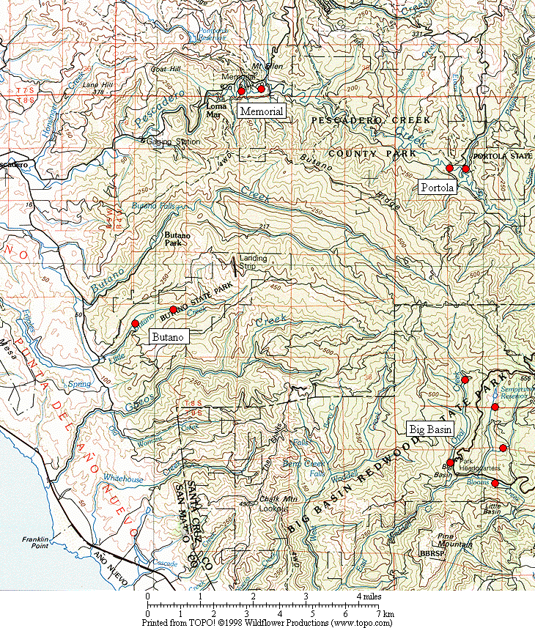

Figure 1. General location of the Marbled Murrelet monitoring stations in the four Santa Cruz Mountains parks.

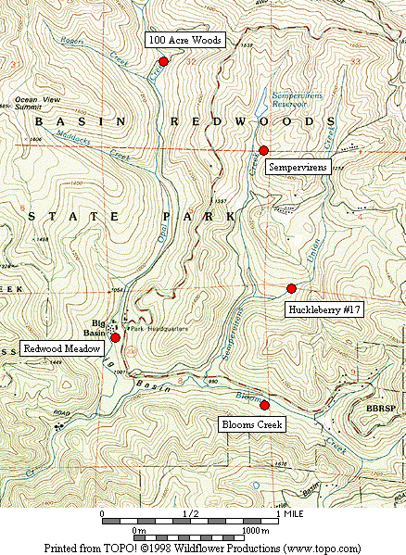

Figure 2. Location of Marbled Murrelet monitoring stations in Big Basin Redwoods State Park.

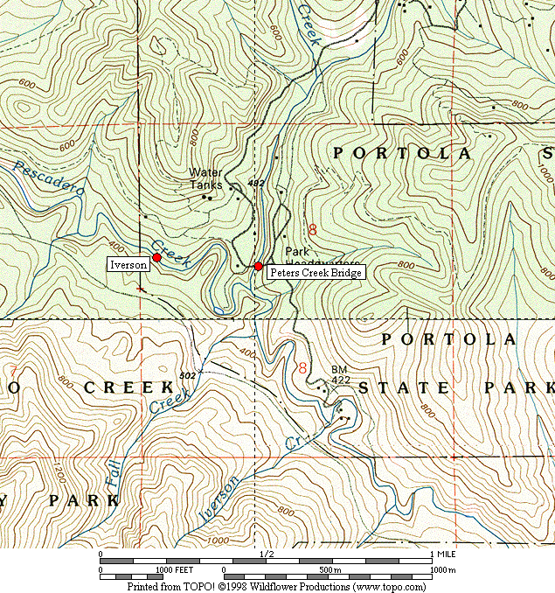

Figure 3. Location of Marbled Murrelet monitoring stations in Portola Redwoods State Park.

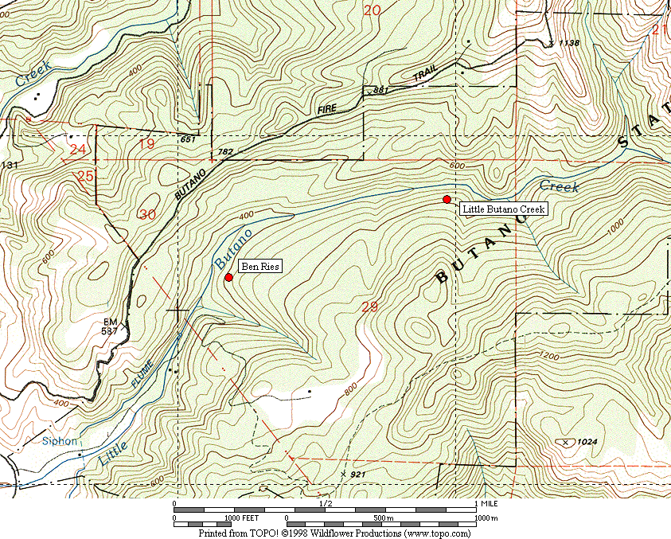

Figure 4. Location of Marbled Murrelet monitoring stations in Butano State Park.

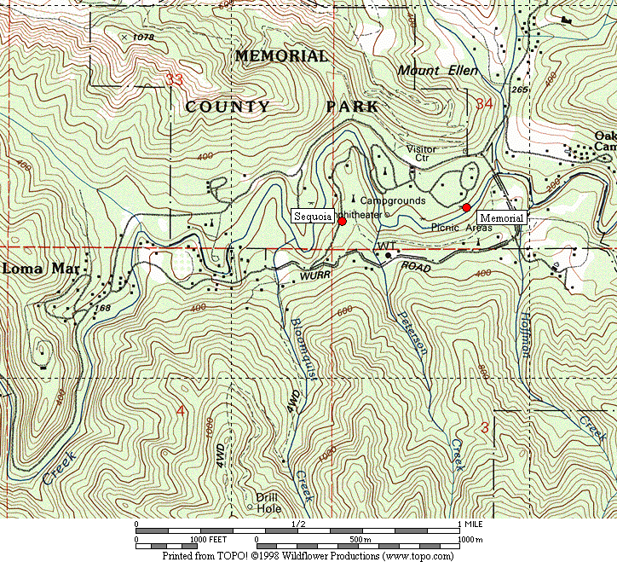

Figure 5. Location of Marbled Murrelet monitoring stations in San Mateo County Memorial Park.

Figure 6. Average murrelet activity on dawn surveys from all five Big Basin stations. (Note: no data from 1997, 1999 or 2000. See Table 2 for standard deviations.)

Figure 7. Average annual murrelet activity at all five Big Basin stations, showing total detections (± s.d) with linear regression trend. (Note: no data from 1997, 1999 or 2000.)

A. Redwood Meadow B. 100 Acre Woods

C. Blooms Creek D. Huckleberry #17 (Note: no
detections were recorded in 2002)

E. Sempervirens (Note: no detections
were recorded in 2002, 2003 or 2004)

Figure 8. Annual activity levels (average total detections) at individual Big Basin monitoring stations from 1995 – 2004. (Note: no data for 1997, 1999 or 2000.)

Figure 9. Average detections from dawn surveys on three consecutive mornings in late June or early July at “Peters Creek Bridge,” Portola Redwoods State Park, 1992-2004. (Note: no data from 1996, 1997, 1999, or 2000.)

Figure 10. Linear regression on average detections from dawn surveys in late June or early July at “Peters Creek Bridge” in Portola Redwoods State Park. (Note: no data from 1996, 1997, 1999, or 2000.)

Figure 11. Relative levels of Marbled Murrelet activity at each park in 2003 to 2004 using total detections.

Figure 12. Relative levels of Marbled Murrelet activity at each park in 2003 to 2004 using detections with occupied site behavior.
Appendix 1. Bird species detected and point count maxima from 2004 dawn Marbled Murrelet surveys. (See footnote for key to station codes.)¹

Big Basin Portola Butano Memorial

Species RM BC HU OA SP PC IV BR LB ME SQ

Wood Duck – – – – – – X² – – 1 –
Mallard – – – – – – – – – 2 –
Common Merganser – – – – – – X – – X 1
California Quail 2 – – – – – – – – – –
Sharp-shinned Hawk X – – X – X – – – 1 X
Cooper’s Hawk – 1 – X 1 – 1 – 1 – –

Red-shouldered Hawk X 1 – – 1 X 2 X 1 2 2
Peregrine Falcon – X – – – X – 1 – – –
Marbled Murrelet ³ 9 X X X – 14 14 10 17 X 6
Band-tailed Pigeon 4 4 4 3 2 2 4 5 6 2 4
Mourning Dove – 1 – – – – – – – 1 X
Western Screech-Owl – X X X X – – X – X –

Northern Pygmy-Owl – – – – – – – – X – X
Northern Saw-whet Owl – X – – – – – – – X –
Vaux’s Swift 1 – – – X 2 1 – – – –
Allen’s Hummingbird X X X – – 1 1 – 1 – 2
Belted Kingfisher – – – – – 1 1 – – X –
Acorn Woodpecker 26 29 17 2 7 3 – 3 – 5 9

Appendix 1, continued

Big Basin Portola Butano Memorial

Species RM BC HU OA SP PC IV BR LB ME SQ

Red-breasted Sapsucker – – – – – – – – – – X
Downy Woodpecker – – 1 – – – – – – – –
Hairy Woodpecker 1 1 X 1 2 2 1 2 2 1 X
Northern Flicker 1 2 3 X 2 2 X 1 – – 2
Pileated Woodpecker 2 4 2 2 4 1 X 1 X 2 2
Pacific-slope Flycatcher 3 3 1 4 4 4 3 4 3 4 2

Black Phoebe – – – – – 1 – – – – –
Hutton’s Vireo 2 2 2 1 2 1 X X – 1 X
Warbling Vireo – – – – 1 – – – – – –
Violet-green Swallow – – – – – 1 2 X 1 2 2
Steller’s Jay 8 10 28 3 3 8 4 10 8 8 26
Common Raven 5 5 4 2 2 5 5 1 2 5 6

Chestnut-backed Chickadee 5 6 6 3 6 8 3 2 2 9 4
Red-breasted Nuthatch – – – – – – – – 1 – –
Pygmy Nuthatch 7 8 5 4 6 8 15 6 3 7 7
Brown Creeper 4 4 4 3 4 3 5 5 3 3 3
Winter Wren 3 1 2 3 3 1 3 3 5 2 1
American Dipper – – – – – X – – – X –

Appendix 1, continued

Big Basin Portola Butano Memorial

Species RM BC HU OA SP PC IV BR LB ME SQ

Golden-crowned Kinglet 1 X – X 1 – – 2 2 2 2
Hermit Thrush 2 3 3 3 1 1 1 – 1 2 –
Swainson’s Thrush 4 – – – – 1 3 1 X 2 –
American Robin 4 6 3 1 1 2 – 2 1 3 4
Wrentit – 2 – – – – 2 – – – –
Hermit Warbler 1 X – – – – – – – – –
Wilson’s Warbler 2 2 1 – 2 1 1 1 4 1 X

Spotted Towhee – 3 3 – – – – – – – –
California Towhee – – – – – – – – – – X
Black-headed Grosbeak – 1 – – – X – – – 1 –
Dark-eyed Junco 4 2 2 – 2 2 – – – 3 2
Purple Finch 1 1 X 1 1 1 – 1 1 1 1
Red Crossbill – – – – – X – 3 – – –
Pine Siskin – – – – – – – X X 1 4

1. Station codes: RM (Redwood Meadow), BC (Blooms Creek), HU (Huckleberry #17), OA (100 Acre Woods), SP (Sempervirens), PC (Peters Creek
Bridge), IV (Iverson Trail), BR (Ben Ries), LB (Little Butano Creek), ME (Memorial), SQ (Sequoia).
2. “X” denotes a species detected during a 2-hour survey, but not detected during any point count.
3. Number given for Marbled Murrelet is the best estimate from one or more detections during a point count.
Appendix 2. Comprehensive Summary of Dawn Marbled Murrelet Surveys at Redwood Meadow / Park Headquarters Area in Big Basin Redwoods State Park 1991-2004.

In addition to surveys conducted at Redwood Meadow specifically for the California Dept. of Fish and Game and more recently the COSTC in 1995-2004, Suddjian conducted numerous additional surveys annually from 1991-2004 at Redwood Meadow and the adjacent parking lot at Park Headquarters. The meadow and parking lot are only 70 meters apart, and surveys in both spots sample largely the same activity (D. Suddjian pers. obs.). Auditory and some visual detections overlap broadly between the two stations. Thus, survey results from these adjacent spots are combined a look at a long-term trend in murrelet activity in the headquarters area.

In 2004 Suddjian conducted 14 additional surveys at the Redwood Meadow / Park Headquarters parking lot area from April 12 to July 25 that were not part of the COSTC contract. A total of 151 surveys (83% by Suddjian) have been conducted at this site from 1991-2004. An average of 10.8 surveys (range 6-18 surveys) have been conducted annually (Figure 2-1).

Murrelet activity remained very low at Redwood Meadow / Park Headquarters in 2004 compared to activity in the early 1990s (Figures 2-2 and 2-3), with a highly significant declining trend (P <0.0001) evident for total detections and those with occupied site behavior. Activity levels in 2004 remained at a continued low ebb that was first reached in 2002. Annual medians, maxima, and minima have exhibited the same pattern, with the median values quite close to the minima in recent years (Figure 2-4). Maxima have varied widely, but show the same declining trend over the 13-year period (Figure 2-4). Average total detections have declined substantially in each of the four months from April to July (Figure 2-5). Activity in 2002-2004 did not exhibit the typical seasonal peak expected in July (Figure 2-5).

Figure 2-1. Number of dawn surveys conducted annually at the Redwood
Meadow / Park Headquarters area in Big Basin from 1991-2004.

Figure 2-2. Average number of detections (± s.d) on dawn surveys at Redwood
Meadow / Park Headquarters, 1991-2004. (Note: see Figure 2-1 for annual sample
sizes. Surveys occurred between April 5 and July 31 each year.)

Figure 2-3. Average number of occupied behavior detections (± s.d) on dawn
surveys at Redwood Meadow / Park Headquarters, 1991-2004. (Note: see Figure
2-1 for annual sample sizes. Surveys occurred between April 5 and July 31 each year.)

Figure 2-4. Annual median, maximum and minimum total detections on dawn
surveys at Redwood Meadow / Park Headquarters in Big Basin, 1991-2004.

Figure 2-5. Monthly average number of detections on dawn surveys at Redwood Meadow / Park Headquarters in Big Basin, 1991-2004.

Appendix 3. Summary of Marbled Murrelet Detections During Coverage of a Breeding Bird Survey in Big Basin Redwoods State Park, 1992-2004.

The “Pescadero, CA” route (#14-319) is part of the USGS’s Breeding Bird Survey (BBS). The route begins in Big Basin just west of Blooms Creek Campground, and proceeds (via Gazos Creek Road, Cloverdale Road, and Pescadero Road) for 24.5 miles to San Mateo County Memorial Park. Birds are surveyed for three minutes at stops located every 0.5 mile. The route passes through various areas of suitable Marbled Murrelet habitat, but over this route’s history murrelets were only detected at the first 10 stops (Figure 3-1); the remaining areas of suitable habitat are not surveyed until after flight activity has ceased for the morning.

Suddjian initiated the “Pescadero, CA” BBS route in 1992, and has sampled it in most years since then. Each survey has occurred between May 29 and June 1. Official results for 1992-1997, and 2001-2004 are available at <http://www.pwrc.usgs.gov/bbs/>. The route could not be covered in its entirety during 1998-2000 due to road washouts and problems with access through a gate along Gazos Creek Road. But in all years except 2000 Suddjian at least surveyed the beginning portion of the route in Big Basin, including all the stops where murrelet activity has been recorded (Figure 3-1).

While the BBS method is not specifically designed for monitoring murrelets at forest sites, it does provide a repeated measure of murrelet activity, and coverage for the BBS at Big Basin was contemporaneous with the other monitoring efforts presented in this report. The first three stops at the very beginning of the route (Figure 3-1) are located in the East Waddell / Opal Creek watersheds in areas that through the early 1990s had very high levels of activity.

Murrelet activity recorded on the “Pescadero, CA” BBS route exhibited a pattern of decline from 1992 – 2004 that closely paralleled the decline recorded by the other Big Basin monitoring efforts (Figure 7 and Appendix 2). Three related measures – (1) total detections, (2) total estimated individuals, and (3) the number of stops where murrelets were recorded – all showed the same pattern.

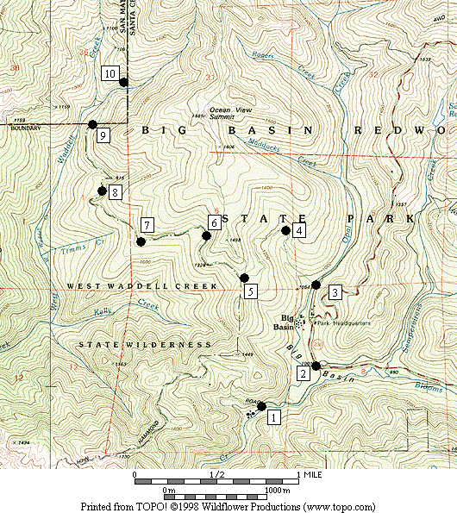

Figure 3-1. Stops on the Breeding Bird Survey route “Pescadero, CA” (#14-319) where Marbled Murrelets were detected on surveys in 1992-2004.

Figure 3-2. Marbled Murrelet activity recorded within Big Basin Redwoods State Park on the "Pescadero, CA” Breeding Bird Survey route in 1992 to 2004. (Note: No data for 2000.)

